**COMP7940 Cloud Computing**

**Group Project Milestone 4**

15 April 2020

1. **How is your project architecture related to the theory taught in the lecture?**
2. **Can you demonstrate, with some screen cap, how to increase capacity of your chat bot service?**

The LINE Bot is currently built on Heroku, which like other cloud providers prices at “pay-as-you-go”. Specifically, the resources of Heroku is measured in terms of dynos, which are Linux lightweight containers Scaling up is achieved by purchasing dynos, if the free dynos associated in the account are not enough. For example, if there are more users subscribed to the LINE Bot account and talk to it, there will be more concurrent HTTP requests, and thereby generate greater traffic volume. In such as case, more web dynos should be purchased.

The Line Bot currently has a few functions, including the query of a PostgreSQL database which stores location details of hospitals in Hong Kong, and query of Redis database, which a web scraper will periodically update with the latest number of confirmed, discharged, hospitalized and death cases in Hong Kong.

The service for PostgreSQL is provided by Heroku PostgreSQL, which divides its services into various plans. Basically, fees will be charged if there are more connections (i.e. number of users of the LINE bot acquires) and more instances that the database will store. Heroku PostgreSQL does provide scale up options, one simply subscribes the different charging plans, based on anticipated usage. The following is a screen cap for different plans and the simplicity of the scaling by only clicking the right plan and install:

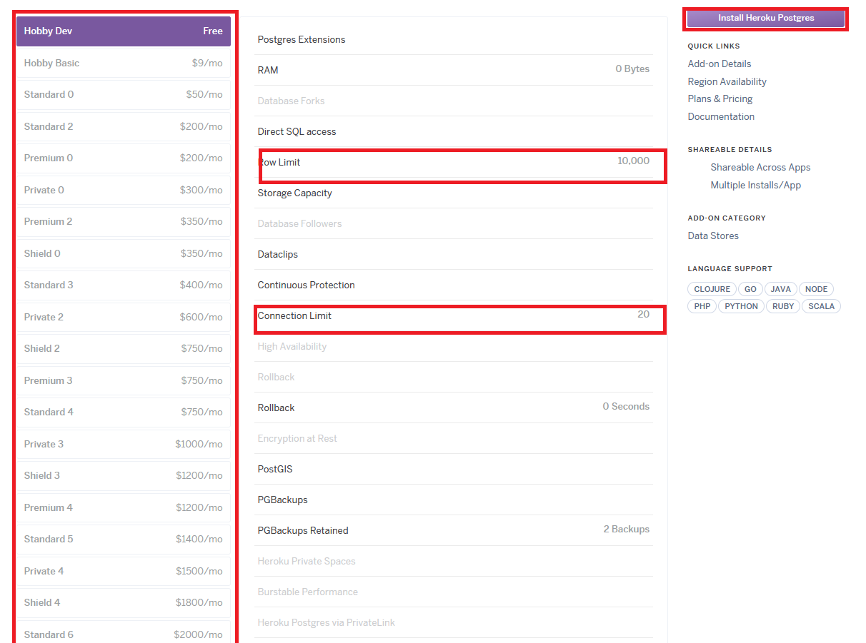

In anticipating the growth in data storage given more and more countries are affected by the pandemic and people may be interested in not only the data in Hong Kong, but also that in overseas, the use of other database service is an effective way of scaling-out. And this is done by way of installing the add-on Heroku Redis.

Similar to PostgreSQL, the service for Redis is provided by Heroku Reis, which also divides its services into various plans. Basically, fees will be charged if there are more connections (i.e. number of users of the LINE bot acquires) and the memory consumed. It can be equally easy to scale up by subscribing charged plans, based on anticipated usage. The following is a screen cap for different plans and the simplicity of the scaling by only clicking the right plan and install:

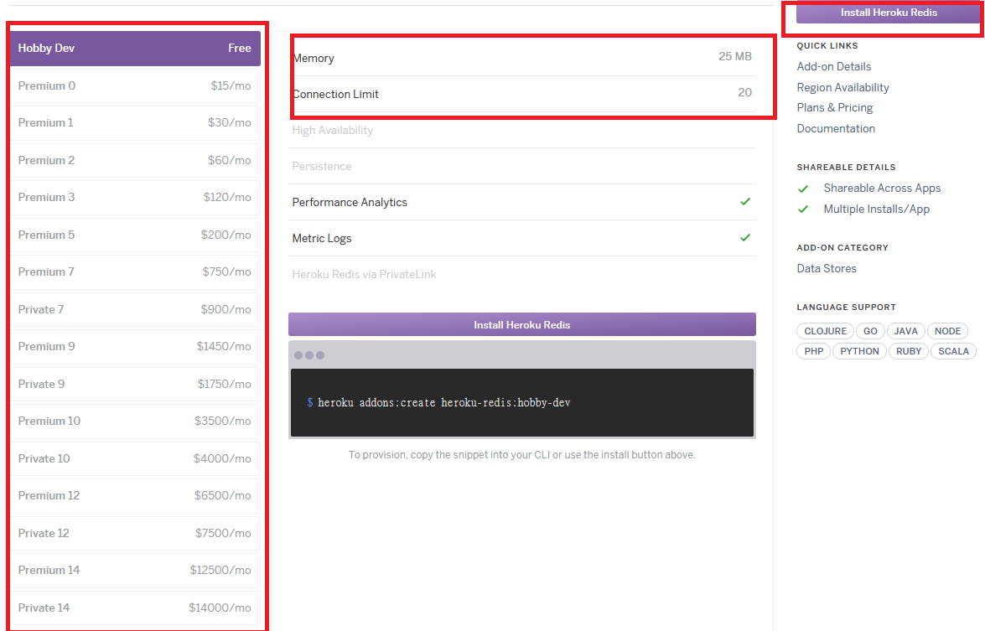

[**Any scaling of other services??**]

1. **Can you identify if you bot is one of the example of PaaS, IaaS, SaaS? Explain your answer.**

The LINE bot is purely implemented on Heroku platform. Although Heroku is known to be a PaaS platform, other services are subscribed to the Heroku services, including Redis and PostgreSQL. So basically, the control of the operating system and middleware components of the LINE bot is rest with Heroku. This essentially lets Heroku be the SaaS service provider. However, when we implement some more other services from other sources, Heroku can still possibly become back to PaaS.

**Group project Group Members**:

Lo Chi Leung (SID: 19451415) (GitHub id: HKBU-DavidLo)

Ye Wei Xiong (SID: 19451407) (GitHub id: handsome168-web)

Zhang Kai (SID: 19404549) (GitHub id: ZHANGSHAO1212)